Rancho BioSciences

April 2018

# ENDPOINTS FOR tranSMART VCF FILTER

**GET AVAILABLE VCF FILTERS**

**PURPOSE**: Gets all available vcf studies in the tranSMART instance

**HTTP_METHOD**: GET

**ENDPOINT**: /api/vcf/studies/get

**ARGUMENT**: NONE

**ARGUMENT TYPE**: NONE

**RESULT**: This endpoint will return a list of VCF studies in the tranSMART instance

**GET AVAILABLE INFO FIELDS**

**PURPOSE**: Gets all the info fields for a VCF study. This will be used to provide the interface a list of Info fields on which to filter

**HTTP_METHOD**: GET

**ENDPOINT**: /api/vcf/info/fields

**ARGUMENT**:

study: The name of the study whose info fields you wish to display

**ARGUMENT TYPE**: URL

**RESULT**: This endpoint will return a list of info parameters for the VCF study selected as well as the type of the data expected for the field

**FILTER VCF TABLE**

**PURPOSE**: Filters VCF tables so based on INFO field parameters, cohort values and sample filters

**HTTP_METHOD**: POST

**ENDPOINT**: /api/vcf/filter

**ARGUMENT**: a JSON string with the format shown below.

{

**limit**: A limit for the number of results to return

**offset**: number of records to skip

**filterParam**:”PASS” or some other value to filter the results based on the filter in the VCF

**cohortOperator**: possible values are (“or” and “and”)

**cohortParams**: [ (If none specified then all samples are used)

{

**conceptPath**: A path to the tranSMART concept on which we are basing the concept,

**comparator**: Possible values are “<”, “>”, “=”,“<=”, “>=”

**value**: the value for the concept we are using to select the cohort

}

]

**zygosity**: Can be either (homo ref, homo alt, het or NA)

**variantOperator**: possible values are (“or” and “and”)

**variantParams**: [

{

**infoField**: values from Get Available Info Fields,

**comparator**: Possible values are “<”, “>”, “=”,“<=”, “>=”,

**value**: desired value of to compare with the infoField parameter,

},

]

}

**ARGUMENT TYPE**: HTTP BODY

**RESULT**: A JSON array of JSON Objects with the Variants that match the INFO parameters sent and the samples that satisfy the cohort and subject parameters specified

e.g.

[

{

sample_cd: G001,

variants: [

{

CHROM:1

POS:84872

FORMAT: GT:AD:DP:GQ:PL

ID:rs99884

REF:G

ALT:A

QUAL: 64

FILTER:PASS

SAMPLE DATA: 0/0:48,0:48:99:0,120,1800

INFO:AF=1.00;AF_SRC=1000G….

}

]

}

]

**FILTER VCF TABLE DOWNLOAD**

**PURPOSE**: Exactly the same as the FILTER VCF service shown above, except it prepares a TSV file for download. Used in conjunction with another endpoint to download the file (described below)

**HTTP_METHOD**: POST

**ENDPOINT**: /api/vcf/filter/download

**ARGUMENT**: Same as FILTER VCF TABLE

**ARGUMENT TYPE**: HTTP BODY

**RESULT**: Name of the TSV file containing the filter results

**DOWNLOAD FILTER RESULTS**

**PURPOSE**: Gets the TSV generated by the FILTER VCF TABLE DOWNLOAD endpoint

**HTTP_METHOD**: GET

**ENDPOINT**: /api/download/filter/results

**ARGUMENT**: filename (from FILTER VCF TABLE DOWNLOAD endpoint)

**ARGUMENT TYPE**: URL

**RESULTS**: A TSV with the filter results from FILTER VCF TABLE DOWNLOAD

## **USING POSTMAN**

The VCF Filter endpoints can be accessed using POSTMAN.

•Download and install postman from https://www.getpostman.com/

•In this example we will try out the filter endpoint. See docs on how to use other endpoints

•Set the HTTP method to POST

•Set the URL to: <server-url>:8080/Transmart_VCF_Filter/api/vcf/filter

•Click on the ”Body” tab and select the “raw” Radio button

•Select JSON (application/json) on the dropdown to the right

•Put in your filter params in JSON format as shown on the image below

•Click the Send button

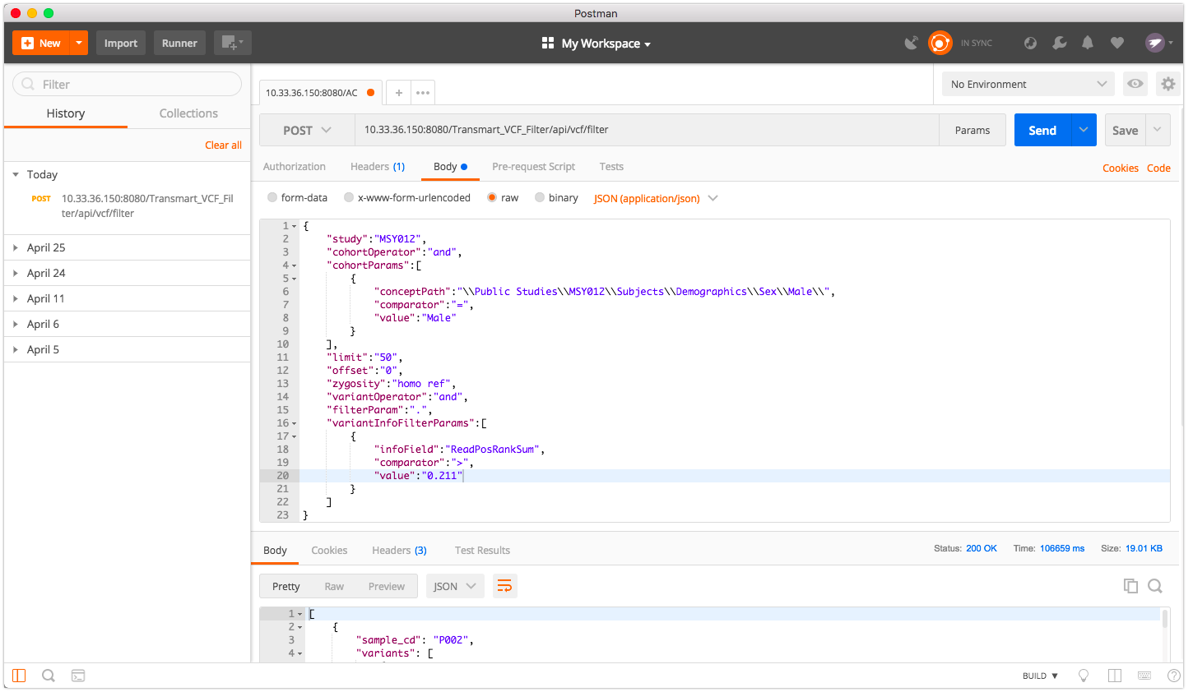

The filter endpoints also have the ability to download the filter results into a TSV file

•Set the HTTP method to POST

•Set the URL to: <server-url>:8080/Transmart_VCF_Filter/api/vcf/filter/download

•Perform the same procedures described above

•The result will be the name of a file with the filter results

•Set the HTTP method to GET

•Set the URL to <server-url>:8080/Transmart_VCF_Filter/api/download/filter/results?study=<name-of-file-with-filter-results>

•Click the “Send and Download”. (On the Mac this Send and Download as a dropdown to the right of the “Send” button)

•Specify the name of the download file

# ****USER INTERFACE****

We have also implemented a rudimentary UI that will allow you to Filter VCFs. The UI is simpler to use than POSTMAN but it does not provide the same amount of flexibility.

•Navigate to http://<server-url>:8080/Transmart_VCF_Filter

•Enter Your Parameters as shown below and click the “Filter!!!” button

•You will get a notification to download a tsv file containing the filter results

